**Lab 6**

**Due date**: At the end of your lab period.

**Purpose**: Demonstrate successfully installing and updating the VM and **Ubuntu Desktop 20.0** as a virtual machine.

**Marks:** 10

**Procedure:** The following instructions will guide you through the installation process for VMware **Workstations 15 and Linux Ubuntu** 20.0

Important Note: In some laptops such as HP or Lenovo the virtualization is not enabled; therefore, you should go to your BIOS and enable it. (F2 or F10)

1-Instruction for Acquiring and installing VMware workstation 15



Login to your **BS (theory section)** and click on **Digital Resources**



Login to **Algonquin College** with your user id and password



Click on **Continue to Digital Resource Portal**

Click on **Your Software** tab and choose **VMware**

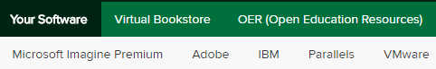

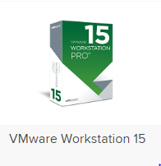

Select **workstation 15.x Pro** for Windows

Note: for Mac machine choose **VMware fusion 11.x pro**



Click on the **Add to cart** tab

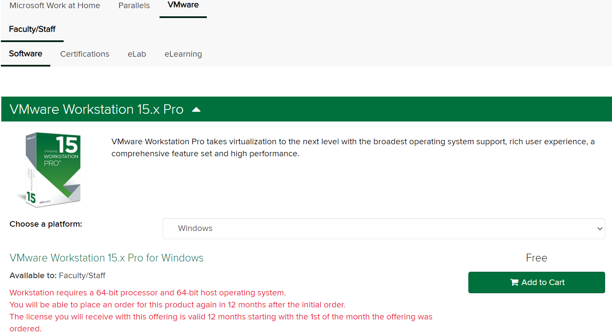

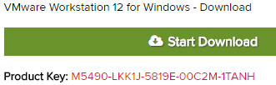

The next screen presents you with the VM product key.

Make sure to **save** this **CD-Key number**. You need it for later. Example

(Important note: Do not change the default directory for download

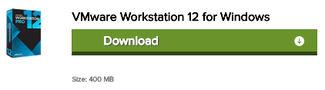

(The Default folder is Downloads)

Click on **Start Download** to download the file.

Files size: 511 MB

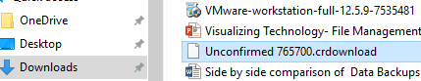

**2-Installing Workstation 15 (VMware )**

Locate the downloaded file and launch the application.

(Usually, it is in the downloads folder) VMware will load

and the installation wizard will start. Click **next**

Choose **Typical** click **Next**

License agreement click Next

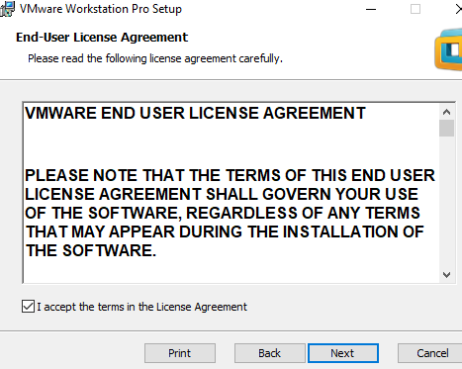



Select the folder to install and click **Next**

Select what shortcuts you want and click **Next**.



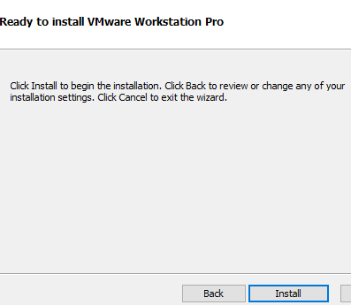

On the **Ready to perform requested operation** page click **Install**

As packages are installed, the status bar will indicate their progress.



Wait for all tools to be installed and don’t be impatient if the status

the bar doesn’t change for a minute or two

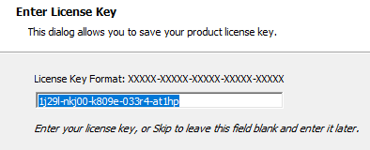

Enter the **license key** found on the order sheet you saved. Press

**Enter** when you’ve done this. Now click on **finish**

Downloading Ubuntu 20.0

Go to <http://www.ubuntu.com/download/desktop> and download Ubuntu 20.0 to a directory on your local hard drive. (**Download folder**)

Scroll down to see this message



**3-Creating a Virtual Machine (installing Ubuntu)**

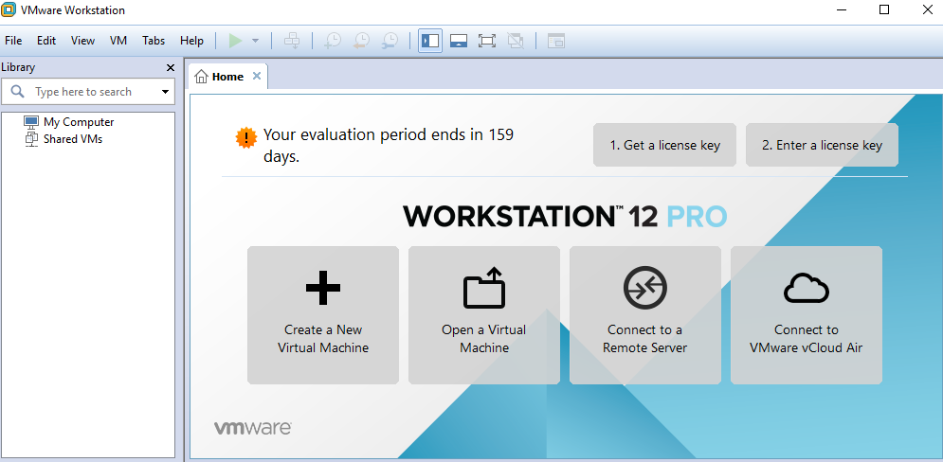

Start VMware Workstation (shortcut on your desktop)

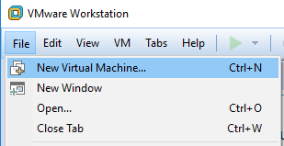

Select **File**🡪**New Virtual Machine**, choose **Custom,** click **Next**

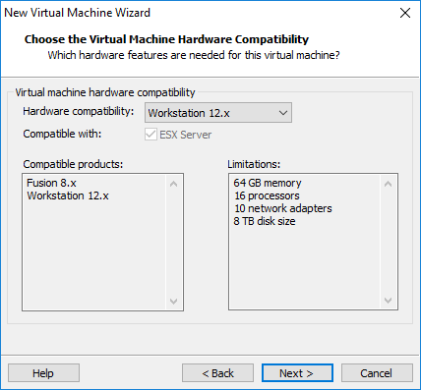

**Click next**

In the **Guess operating installation** page

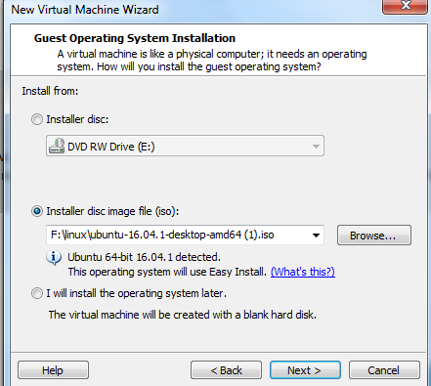

Choose **installer disc image files (ISO)** radio button

And then click on the **Browse** tab to find your Ubuntu file



You should see this path

Then select **I will install the operating system later radio button** (the same page)

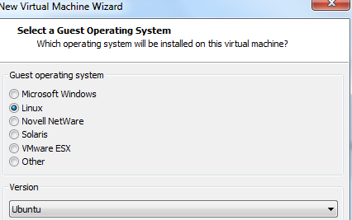

Select **Ubuntu** click **Next**

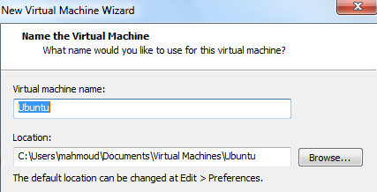

Name the virtual machine **(Ubuntu )**

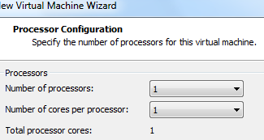

**Process configuration** page, keep the default value click **next**

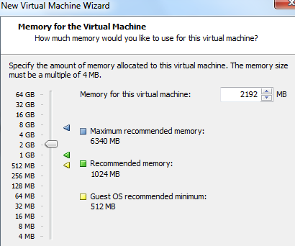

Specify **2 GB** or more of memory click **Next**

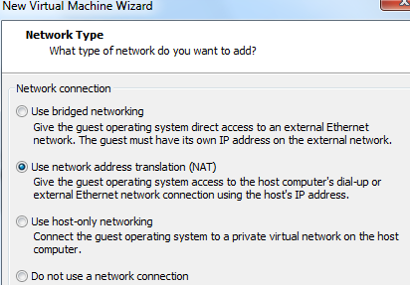

Network type; keep the default value Use **Network address**

**Translation (NAT)** and click Next

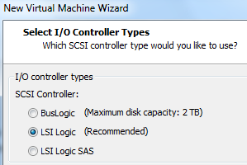

**Select I/O Controller types**. Keep the default settings.

Click **Next**

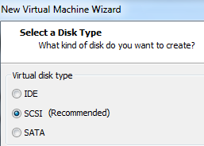

**Select a Disk Type**. Keep the default setting. Click **Next (Exam)**

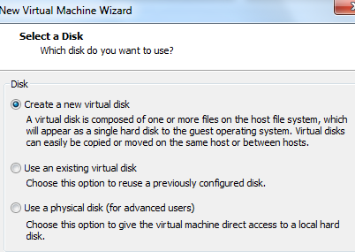

**Select a Disk** (default)

**Create a New virtual disk**



**Specify Disk Capacity** set **the Maximum disk size (GB**): Field to **30**

**GB**. Keep the default **Store virtual disk as a single file** option. Click

**Next**



**Specify Disk File**. Keep the default settings. (i.e. Ubuntu.vmdk)

Click **Next**



**Ready to Create Virtual Machine**, Verify the information in the

table is correct and if so click **Finish**. Otherwise, click the **Back**

button and make corrections.

The **summary** page for the Ubuntu virtual machine is now visible

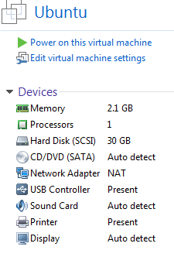

Follow part 4 now

**4-Mount (installing) the Ubuntu image file (Linux)**

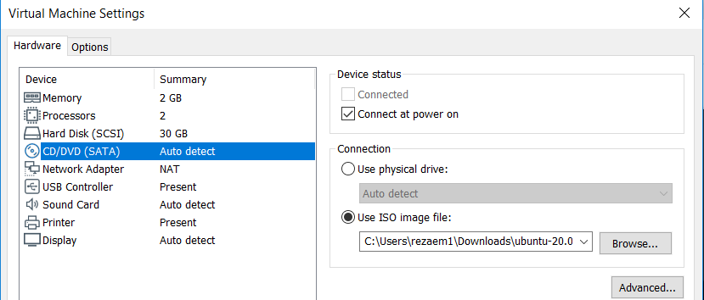

Mount the ISO image to the Ubuntu virtual machine,

From the **Summary p**age, double click on the

**CD? DVD (SATA**) device. This brings up the virtual

Settings dialog

In the Virtual Machine setting dialog box under

**Connection**, select the **Use ISO** image files radio

Button and browse to the location of the Ubuntu ISO (downloads folder) file. Click **OK**

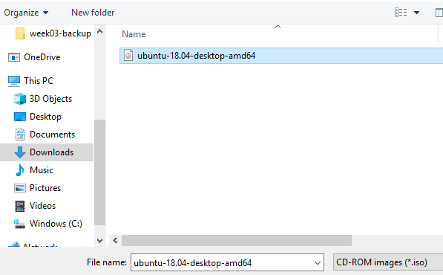

Under Ubuntu click on **power on this virtual machine** to turn on the virtual machine

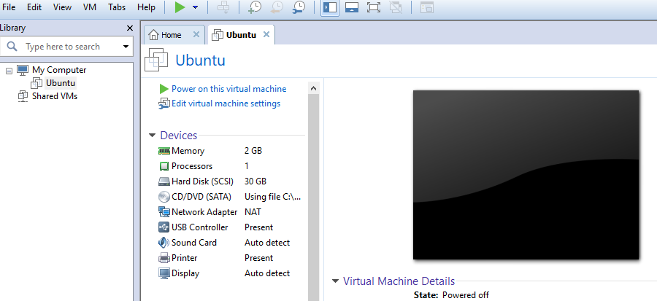

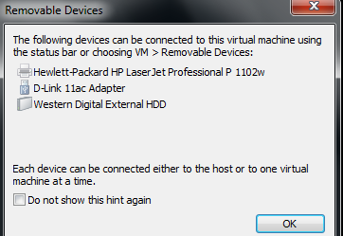

Note: If you see this page just click **ok**

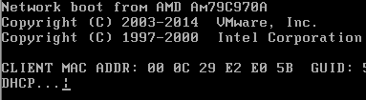

**Note**: if you got a black screen with a slash is spinning,

That means the virtual machine did not find the **Ubuntu file**.

In your VM machine on the menu bar (blue color), click

On the **VM** tab and choose **Power** and click on **Power off**

**Shut off** your virtual machine**.**

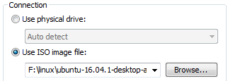

Go back to the **summary** page and under **connection** select

**Use ISO image** file again click on **browse** and locate your

**Ubuntu ISO image** files and click **ok**

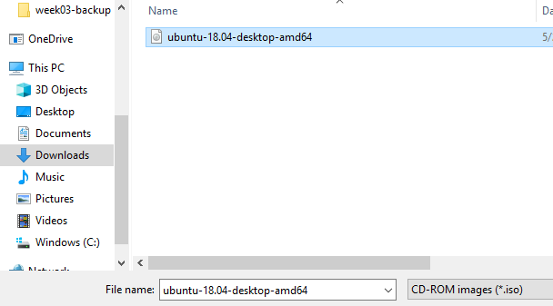

**5 Installing Ubuntu into the Virtual machine**



In the **Ubuntu** tab, go to the **Commands** section and

click on **Power on this virtual machine**. If a pop-up window

emerges about the "keyboard hook timeout", click **OK**

on the **Welcome** page click on the **Install Ubuntu** tab

choose **Linux to** click next

In the **Preparing to install Ubuntu** page just click **Continue**

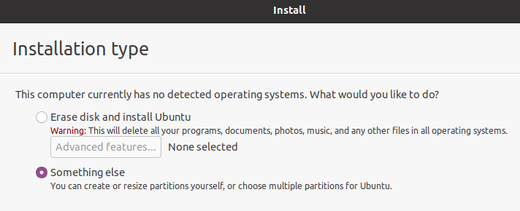

**Installation type,** choose **something else,** click **Continue**



In the **installation type**, click on **New partition table**

You may get this message, click **Continue**



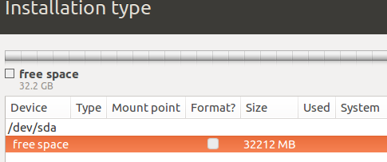

In the **installation Type** unde**r free space (orange)**

Click on the **plus + sign**

Create partition choose these settings:

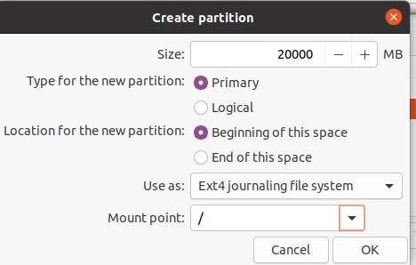

Size: **20 000**MB (20 GB)

Type for the new partition: **Primary**

Location for the new partition: **Beginning of the space**

Use as: **Ext4journalling file system**

Mount point**: / (root)(exam)**

Click OK

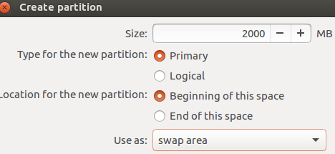

Highlight the **free space** again and click on the **Plus + sign**

To create a **swap area** partition (virtual memory) (exam)

Size: **2000** MB (2 GB)

Type for the new partition: **Primary**

Location for the new partition: **Beginning of this space**

Use as: **swap area**

Click **OK**

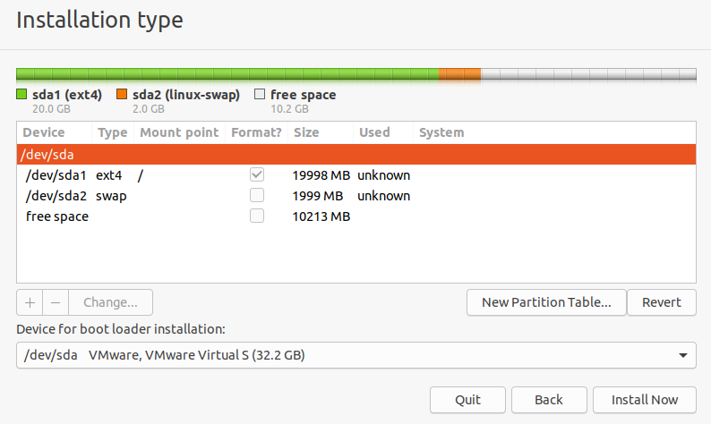

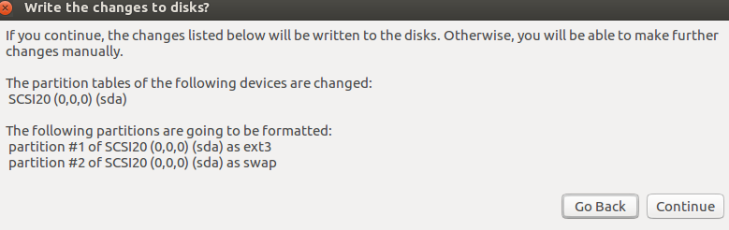

Click on **Install Now**

Warning: **write the change disk?**

Click **Continue**

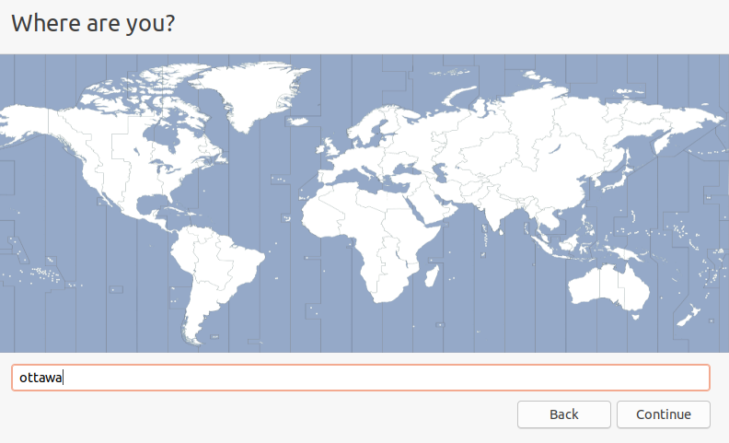

W**here are you**? Type: **Ottawa** and click **continue**

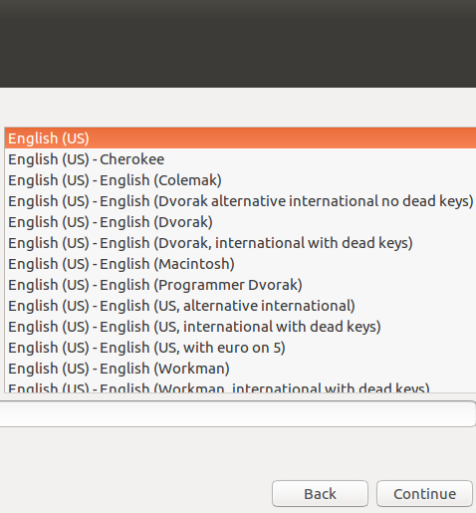

Keyboard layout **English**, click **Continue**

**Important note:** If you don’t see the **Continue** tab

Move your mouse on top of the screen (the black/gray area)

and move the page to the **left.** You should be able to

see the **Continue** tab now.

**Setup the username**

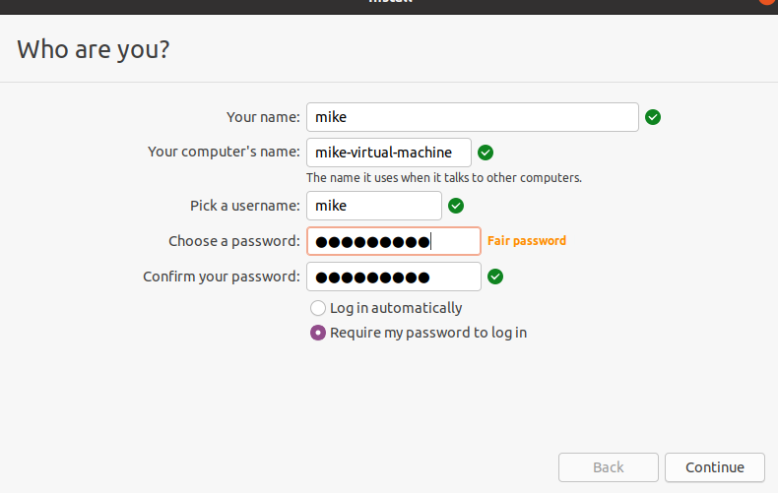

Provide a username and password

Goto the default settings

Click **Continue**

**Welcome to Ubuntu** screen begins to install the **Ubuntu** files

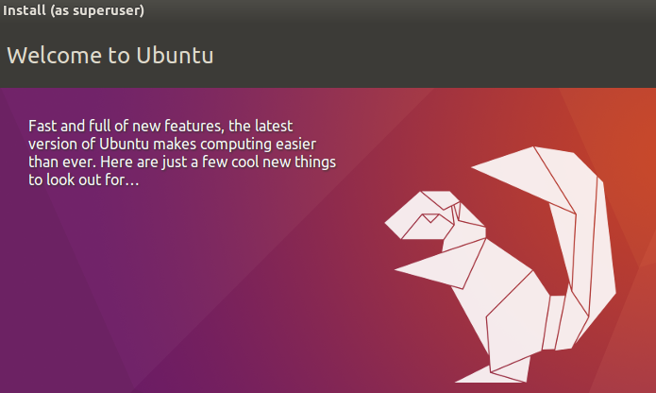

**Note:** this part takes a few minutes

Once Ubuntu is finished, it would ask you to restart your machine

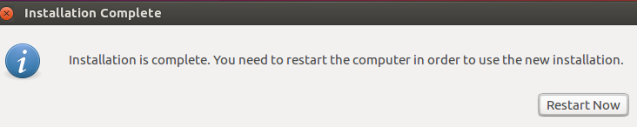

Just click on **Restart now**

You are done**. Press Enter**

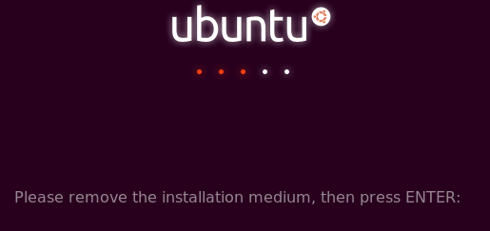



**Note**: When the new operating system boots, you **may/may not**

see errors such as these. If so, click **I Finished Installing**

on the bottom of the **Ubuntu** tab in VMware Workstation.

Click on the error screen and press **1** to reboot, or **power off/on** the

Ubuntu again, Be patient……

Ubuntu should boot normally. When the Ubuntu boot screen



Appears, click on the account you have created, and log in as that user.

**Important note**: if you are missing your mouse inside of your computer

(Virtual machine) just press **Ctrl+Alt (exam)**

**Update Ubuntu Linux 18.0**



Open your Ubuntu, choose **show Applications,** and then click on the **software update**

